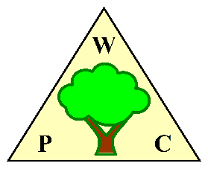
WOODPLUMPTON PARISH COUNCIL
MINUTES for MEETING TO BE HELD IN

THE PARISH ROOMS, REAR OF ST ANNE’S CHURCH WOODPLUMPTON ROAD, PRESTON

ON MONDAY 17th June 2024 at 7.00pm

PRESENT Chairman Paul Entwistle

Councillors: Pauline Bamber Maureen Entwistle Daniel Guise
John Green Barry Probin
County and City Councillors: None Attended
Mr D Mills (Parish Clerk)
members of the public as detailed on the attendance log.

- APOLOGIES
Apologies were received from Councillors Matthew Greaves and Martin Stewart.
- APPROVAL OF THE MINUTES of the Parish Council Meeting held on 20th May 2024.
Min 24/25 023 Members approved the minutes. The Chairman signed the Minutes as a true record.
- TO ACCEPT DECLARATIONS OF INTERESTS AND TO CONSIDER ANY WRITTEN REQUESTS FOR DISPENSATIONS
Councillor John Green declares an interest in item 15 Broughton High School as he is a member of the Broughton High School PTFA.
- PUBLIC PARTICIPATION
The closure of Whittle Hill remains an issue for some local residents. Residents have requested a breakdown of costs to show the individual cost of the closure of Whittle Hill – this has been requested from LCC. Residents have also requested a copy of the LCC swept path analysis for the White Cross junction – this has been sent.

There was a discussion about what will be done to improve the White Cross Junction with no plans to reopen Whittle Hill.

Paul Entwistle explained our multi-faceted path forward, which includes:

- Signage to warn motorists as they approach the junction.
- SPIDs to both encourage motorists to slow down and to record speed data.
- A formal LCC review of the junction, taking place 6 months after the change hence end of June 2024. The council hopes that physical changes to the white cross junction will flow from this review.
- Further lobbying of LCC, once speed data is available from the SPIDs.

- NEWSHAM HALL / WOODPLUMPTON ROAD JUNCTION AND WHITTLE HILL
The Parish Council has placed orders for signs to warn drivers on the approaches to the junction and for 2 SPIDs to indicate the speed of vehicles as they approach the junction from either side.

The LCC monitoring period for the junction runs until the end of June 2024, LCC have indicated that they will provide output for the Council Meeting in July.

- CONSULTATION ORCHARD PLAY AREA.
Work is progressing on the Orchard parking scheme, with the next step being an onsite meeting involving John Gibson and Shirley Parkinson to consider possible options.

- CATFORTH TRAFFIC CALMING SCHEME
The latest update is that TROs are being prepared and will be issued in around 6 weeks.

- LINEAR PARK
MIN 24/25 024 The Council Resolved that The clerk should write again to Chris Hayward to seek an understanding of when the Parish Council will be able to start working with PCC on the development of the linear park.

PCC have provided feedback on projects where a CIL liability was either identified or was likely following planning approval. There appears to be very little certainty around when and how much CIL money will be paid. The main factors were:
- Projects not proceeding
- Developers seeking CIL exemptions (usually self-build)
- Projects being modified
- Stage payment arrangements being agreed
These factors have led to PCC not having a forward forecast of the flow of CIL money, hence we cannot use their forecast to predict our share.
PCC have promised to now send copies of all CIL Demand Notices to the Clerk, which should provide a short term forecast.

- FINANCIAL STATEMENT 31 May 2024
MIN 24/25 025 Members Resolved to Approve the End of May Financial Position

The Chairman signed the parish account statement verified with the End of May Bank statements. (Docs attached)

The End of May Balances were:
Current Account £152,813.31
CCLA Account £297,742.38

- ACCOUNTS FOR PAYMENT AND RECEIPTS 30 June 2024
MIN 24/25 026 Members noted and approved the following accounts already paid after the May meeting in accordance with Standing Order 15 (b) xii
DETAILS | PAYEE | AMOUNT | REF
May payments Prior to Meeting
Lengthsman Invoice May 2024 | Lengthsman | £1520.00 | Ref 30
Lengthsman Expenses May 24 | Lengthsman | £8.99 | Ref 31
Purchase of Maps for Bins | PCC Sundry Debts | £89.35 | Ref 32
WPC Insurance | Clear Councils | 549.09 | Ref 33
Pension Payment Clerk | NEST | 59.13 | Ref 34
SPID Purchase Newsham Hall Lane | Traffic Technology | 7732.80 | Ref 35
Garden Invoice May 2024 | Lengthsman | 326.48 | Ref 36
Repair to Hedgetrimmer | Lengthsman | 135.63 | Ref 37
Printer Purchase | Viking Direct | 454.80 | Ref 38
Posts for SPIDs N Hall Lane | Lancashire CC | 957.60 | Ref 39

- ACCOUNTS FOR PAYMENT AND RECEIPTS
MIN 24/25 027 Members approved the following accounts for payment

Bank Charges | £0.30 | Deduct | Ref 40
Clerk Salary June 2024 | £773.54 | BACs | Ref 41
HMRC PAYE | £557.33 | BACs | Ref 42
Employer National Insurance | £83.72 | BACs | Ref 43
Parish Room Rental Meet the Councillor | £50.00 | BACs | Ref 44
Parish Room Rental June Meeting | £50.00 | BACs | Ref 45
Pay Previous Clerk | £300.06 | BACs | Ref 46
Previous Clerk Expenses | £16.47 | BACs | Ref 47

- Bowser Purchase
MIN 24/25 028 Members approved the purchase of the water bowser described below, for the watering of planters once these are in place at a cost of £4,030.80. including VAT. The Bowser has a gross weight of 750Kg making it suitable for towing with a lightweight vehicle. The Bowser will be stored at the clerk’s property when not in use.

500 Litre Highway Tow Potable Water Bowser  Extended Chassis  + 1” Petrol Pump  15ft hose on a post  Total Delivered cost £3359+vat – customer to offload | 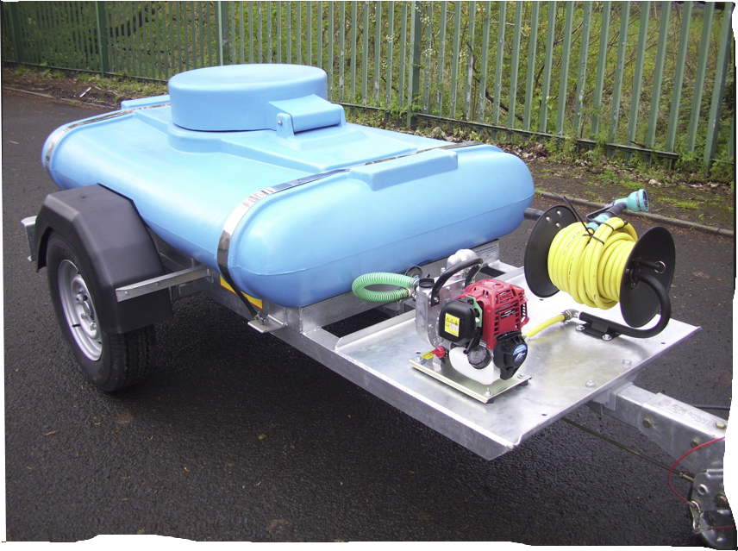
The purchase will only be made once we are progressing towards purchasing planters.

- WARDING ASSESSMENT
The Warding Assessment Team will finalise the document and circulate to the Councillors for comment. The document will then be included on the agenda of a subsequent council meeting for discussion.

- NEW ESTATES MAINTENANCE
Cllr John Green now has copies of the Section 106 agreements for the larger new build estates in the Parish, which he will review.

- REQUESTS FOR SUPPORT

Broughton High School
Councillor Green has spoken to Broughton High School. They are looking for some help with a number of Canopies that they want to build around the school site.
Whilst the school is technically outside the parish, a large proportion of the parish’s secondary school children attend the school. There are a total of 222 children from the parish in the school, representing around a quarter of the school population.

The school’s comments:

"There are numerous areas where we have circular eight seater picnic tables available, not all are under canopies meaning that when we have inclement weather these tables cannot be used. It would enhance our site considerably and mean that, when it is wet, pupils do not have to rely on staying in busy indoor dining areas to stay dry. It also means that the distribution of pupils across the school site is more even for staff on duty. We would welcome the opportunity to show members of the Parish Council our wonderful site, should they wish to visit school."

They are looking to build a number of canopies each costing approximately £15k dependant on size and would like to ask the parish if they'd be prepared to fund one or more of these for the school.

The Council discussed the merits of the request and concluded that in line with their response to previous requests they would not support a request from a government funded entity such as a school, where state funding should cover such costs. A further reason for the refusal was that the school requesting support was not within the parish.
The decision was made by a vote, with 4 Councillors opposed, 1 Abstaining and 1 having a conflict of interest.
MIN 24/25 029 Members rejected the request for a grant to Broughton High School.

Ribbleswood Bridge
MIN 24/25 030 Members resolved to fund the replacement of the Ribbleswood Bridge at a cost of up to £25,000.

- GRIT BINS
The council agreed to identify locations across the Parish where grit bins would be useful. These would then be considered against LCC criteria to see if they are justified for LCC supply and filling or whether they would need to be purchased and filled at Parish Council expense.

A proposal identifying the number of Bins that the Parish Council will need to purchase and fund the filling of will be brought forward to a future meeting.

- RED TELEPHONE BOXES
MIN 24/25 031 Members resolved not to further consider the purchase of red telephone boxes.

- WOODPLUMPTON FETE
Preparations for the Fete are in progress and a Bank account should be available by the end of June, to receive the WPC grant.

- PLANNING APPLICATIONS BEFORE COUNCIL
MIN 24/25 032 Members approved the delegated comments for May.
- BINS AND PLANTERS AROUND THE PARISH
MIN 24/25 033 Members resolved that the new bins in the parish should be labelled

“Woodplumpton Parish Council in Partnership with Preston City Council”
PCC is progressing with the purchase and siting of the bins in the agreed locations.
Work on the siting of planters will commence now that the WPC work to install bins has been completed.
- UPDATE ON ISSUES FOR INFORMATION
Councillor Paul Entwistle brought forward a picture of a plastic maintenance free bench that could be considered for locating around the parish. Councillors agreed to consider possible locations so that a proposal could be brought forward for consideration at a future meeting.

- DATE OF NEXT MEETING
Members are requested to note that the next meeting is scheduled to take place on Monday 8th July 2024 at 7.00 in the Parish Rooms.

END

